**1.Create a directory’project_dir’& cd to ‘project-dir’.**

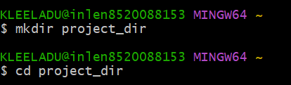

**2.Initialize git version database.(git init).**



**3.Create a new file index.html.**



**4.Check the git status. You should find index.html as untracked file.**

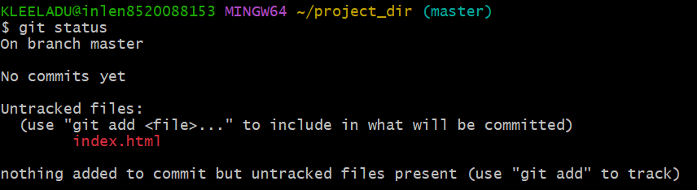

**5.Stage the index.html file.**



**6.Commit index.html.**

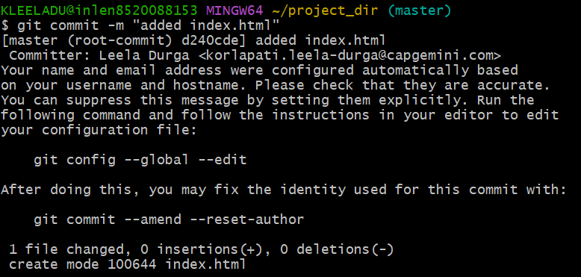

**7.Make few changes in index.html& create a new file info.txt file.**

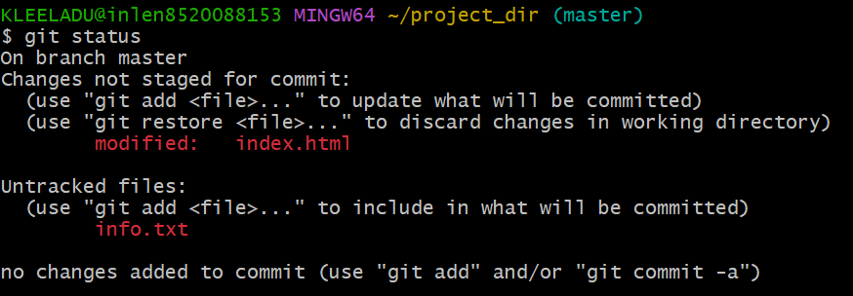

**8.Check git statuinfo.txts. You should find index.html& info.txt as untracked files.**

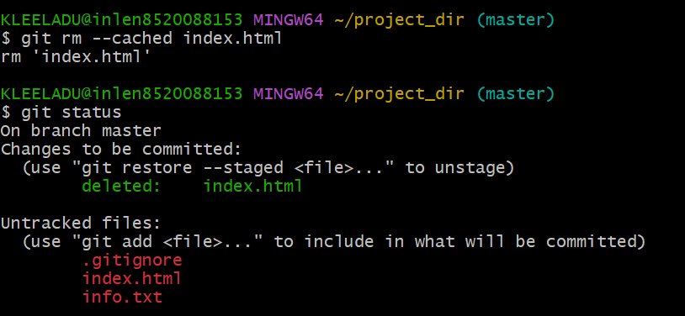

**9.Configure GIT to ignore all txt files.**



**10.Again check the git status.You should find only index.html as untracked file.**

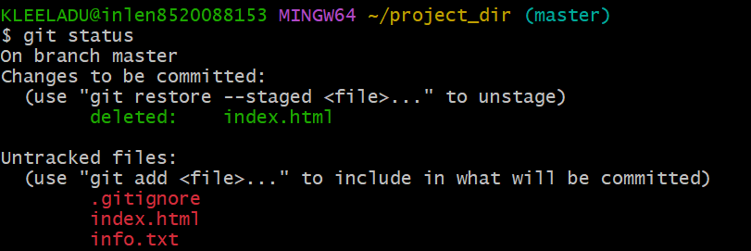

**11.State & commit index.html**

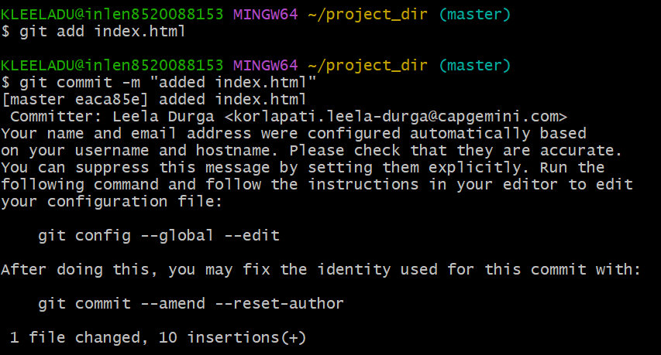

**12.Log all your comments so far.**

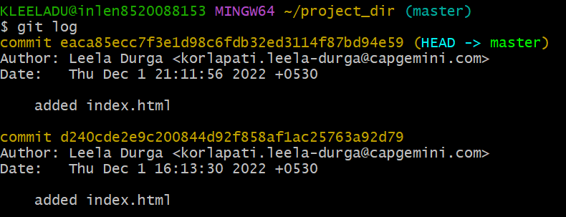

**13.Make some changes in index.html.**

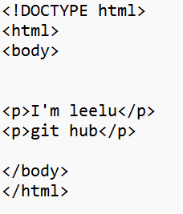

**14.Revert the change made in the previous step using git command.**

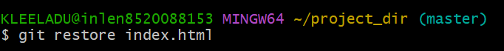

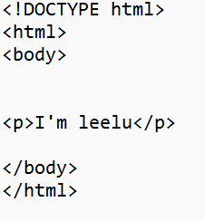

**15.Again change index.html.**

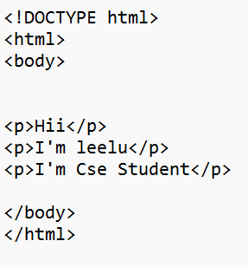

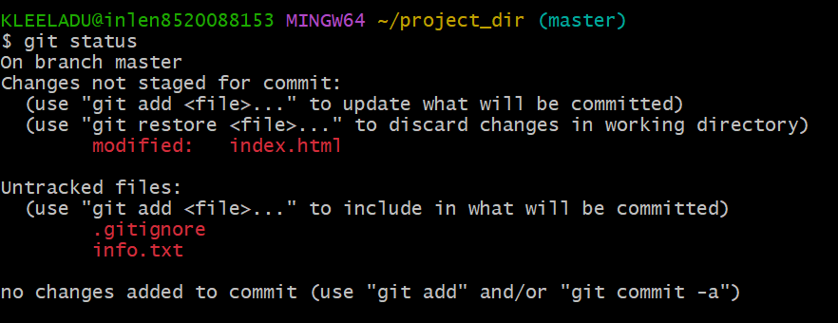

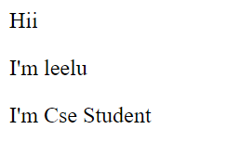

**16.Stage index.html**

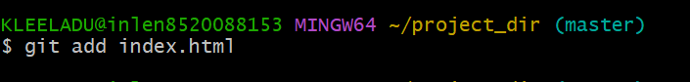

**17.Revert back the last stage.**

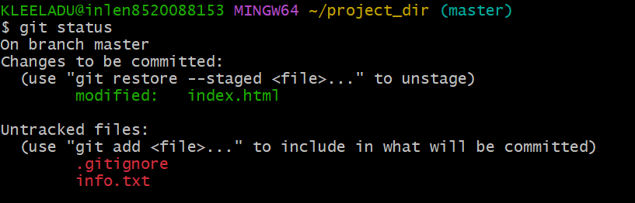

**18.Rename ‘add’ command to ‘my-add’.**



**19.Using my_add command Stage index.html again&commit the changes.**

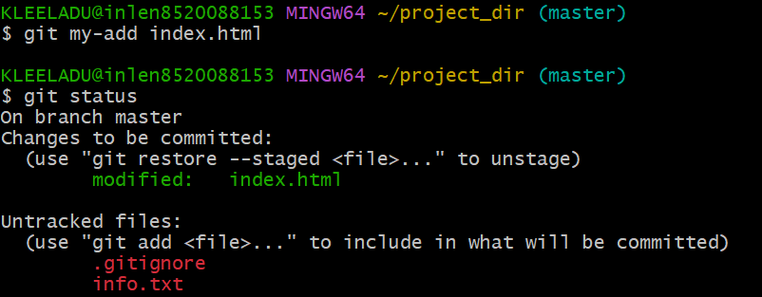

**20.Revert the last commit.**

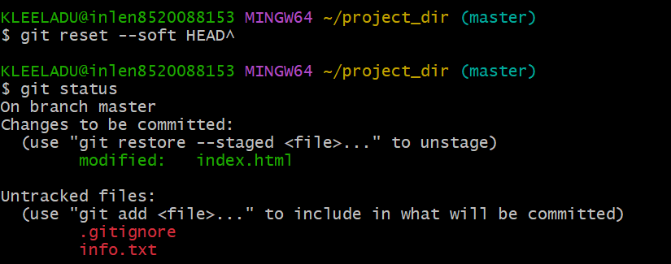

**22.Create an empty directory’Assignments’ and cd to ‘Assignments’.**

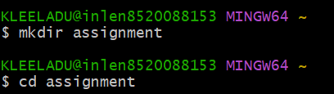

**23.Create a file readme..txt inside ‘assignments’ and write few lines about the contents of ‘assignments’ folder.**



**24.commit readme.txt file.**

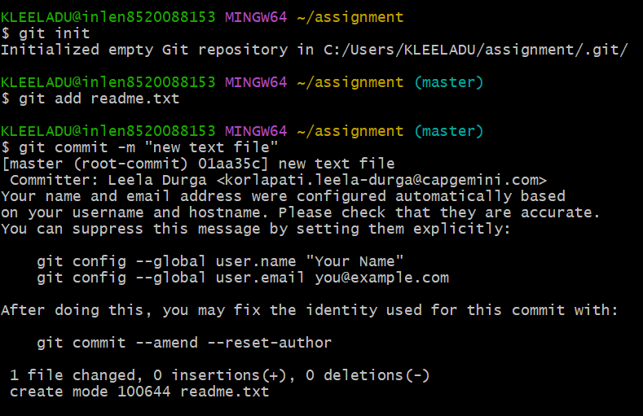

**25.now create a new branch ‘html-assignments’.**



**26.switch to ‘html-assignments’.**

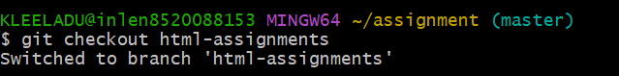

**27.copy all HTML assignments inside’assignments’ folder.**

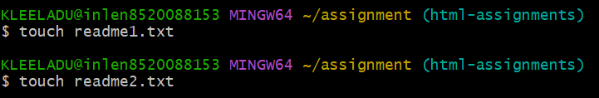

**28.Commit HTML assignments into ‘html-assignments’branch.**

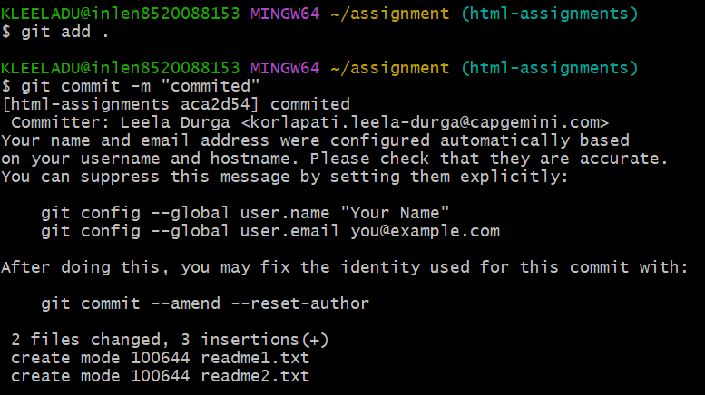

**29.**

**30.**

**31.switch to master branch.**

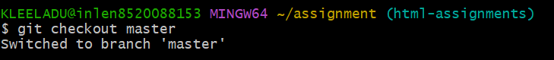

**32.Make minor changes into README.txt file & commit those changes into master.**

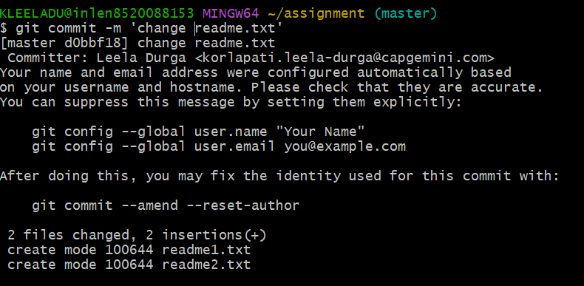

**33.Again switch to ‘html-assignments’ branch.**

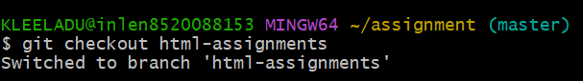

**34.Make minor changes into few files belonging to ‘html-assignments’ branch.**



**35.Commit those changes.**

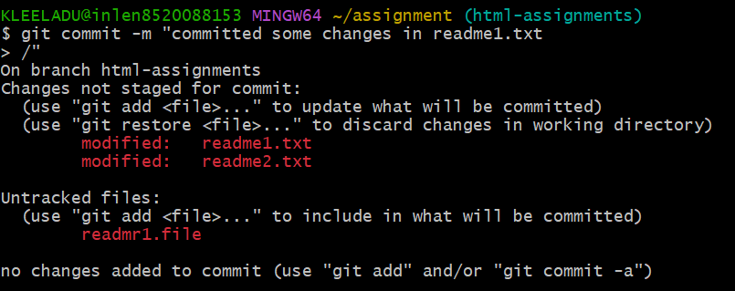

**36.Switch to master.**



**37.**

**38.**